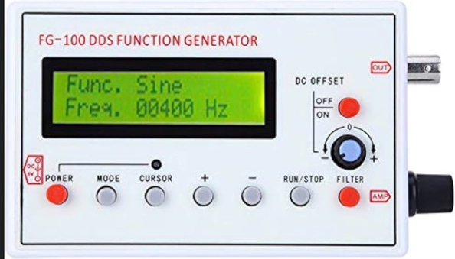
How to use the function generator and oscilloscopes:

Function generator:
- To allow it to power on, use a DC plug on the left side and have it connected to a power outlet. Click the power button.
- On the right side, using the top silver output insert a splitter with banana jacks.
- One set of the red and black cords will connect to the oscilloscope, and the other set will connect to the transmitter.
- The mode button will change how the waves appear on the screen of the oscilloscope. The main mode used is sine.
- The cursor button allows you to move digits to the right and the plus or minus will change the number where the cursor is over.
  - If using a 40KHz receiver and transmitter, the number should read 40000 Hz.
- The DC offset button will move the yellow line on the oscilloscope up or down.
- The AMP dial will make the sound waves on your screen appear bigger or smaller.
- When all the settings are correct, click the run/stop button. If any setting ever needs to be changed, click the run/stop button to edit the settings.
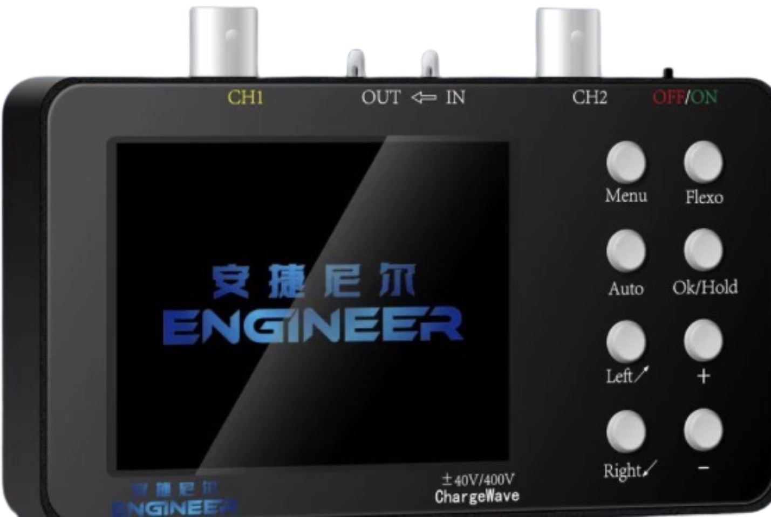
Oscilloscope 1:
- To power on, plug in USB-C cord into the right side of the oscilloscope and flip it to on with the switch on the top right. If fully charged, it will not need to be plugged in.
- Put splitters on each of the silver channels on the top. Insert the second set of black and red cords from the function generator into the splitter of CH1.
- In the splitter of CH2, insert the black and red cords from the receiver.
- The left and right buttons are used to move the cursor to allow for things on the screen to be selected and changed. Things can be changed by using the + and – buttons.
- The Ok/Hold button pauses the screen.
- In the top right corner of the screen there is a box that can say auto, single, or normal. Single freezes the screen and auto is the most used.
- The top and bottom left boxes are not needed to be changed. Auto can be used instead.
- The bottom middle box when increased, zooms out and vice versa.
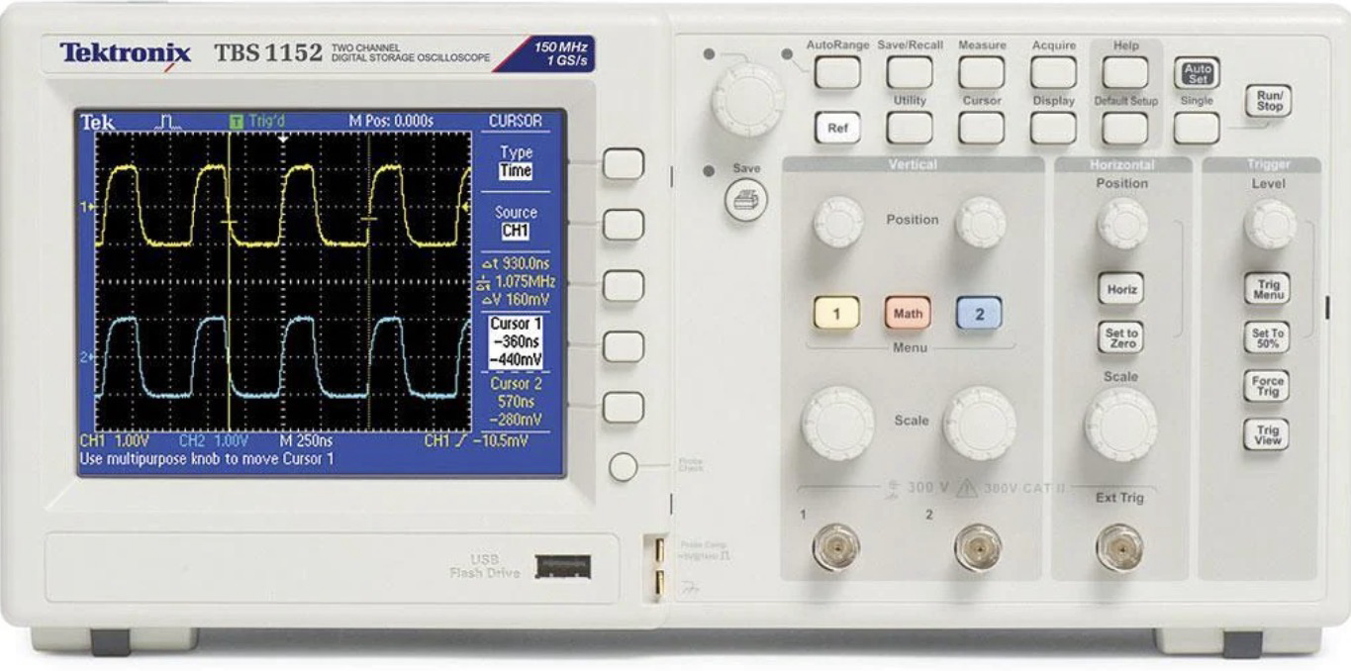

Oscilloscope 2
- Plug power cord in back and connect to power source.
- Put splitters on each of the silver channels on the bottom of the front. Insert the second set of black and red cords from the function generator into the splitter of 1.
- In the splitter of 2, insert the black and red cords from the receiver.
- Power button is top left of machine, press it down to turn it on.
- In the vertical dark grey rectangle, there are four dials.
  - The top left dial moves the yellow wave from the transmitter up or down.
  - The top right dial moves the blue wave from the receiver up or down.
  - The bottom left dial makes the yellow wave bigger or smaller.
  - The bottom right dial makes the blue wave bigger or smaller.
- The Horizontal box only has two dials.
  - The top one moves both waves to the left and right.
  - The bottom one makes it take longer or shorter to move across the screen.
- The trigger box only has one dial.
  - It freezes the trace.
- The top dial, not in any box, changes the setting from auto to triggered.

SET UP PICTURED:
